Smoked Haddock, Leek & Orzo Gratin
One of my favourite gifts this Christmas was a cookbook by Jane Lovett from my son Hugh and this is our new fave recipe using our delicious Smoked Haddock and Welsh Angiddy Cheese. Really creamy and comforting and so tasty. Enjoy x
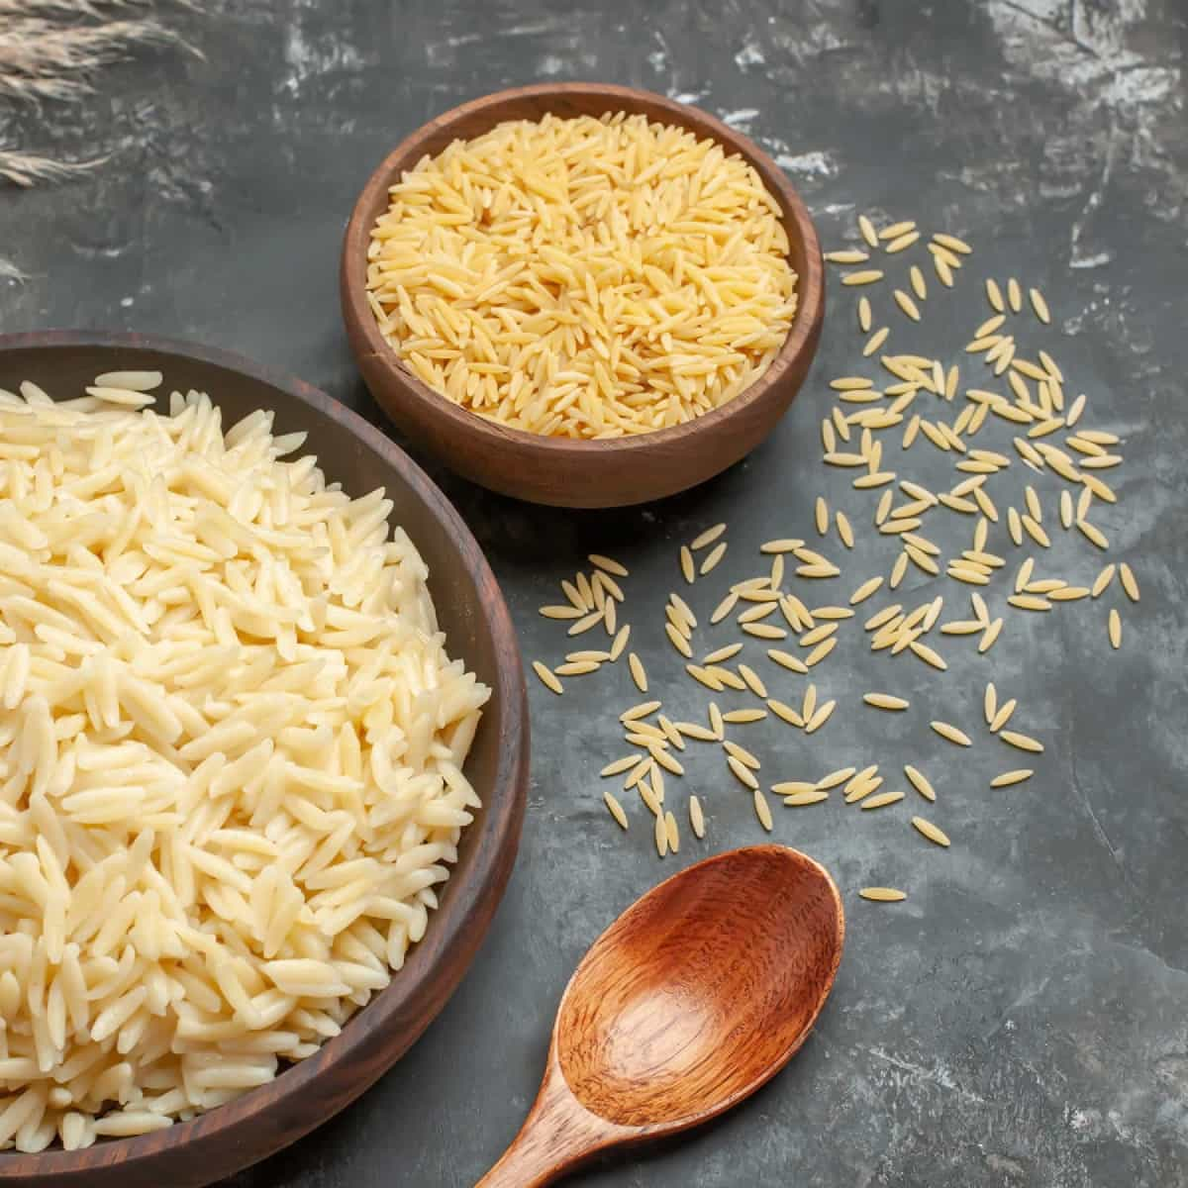

Ingredients

Fino Olive Oil
1 x Onion finely diced
1 x leek sliced
300g orzo
1 litre fish/chicken stock
340g Black Mountains Smokery Smoked Haddock
200g Angiddy Cheese diced
5 tbsp double cream
3 tbsp Parmesan cheese grated
3 tbsp breadcrumbs
Small bunch chopped parsley
Salt & pepper

Preheat oven to 220C
Soften the onion and leek in olive oil
Stir in the orzo and add the stock. Bring to the boil and simmer until the pasta is al dente.
While the pasta cooks dice the smoked haddock. Take off the heat and stir in the haddock, the cheese and the cream.
Tip the mixture into an ovenproof dish and sprinkle with the parmesan and breadcrumbs
Bake until golden and scatter with parsley. Serve with steamed green vegetables or a green salad.

