BUCKWHEAT & LAVERBREAD PANCAKES WITH SMOKED SALMON & CITRUS CREAM

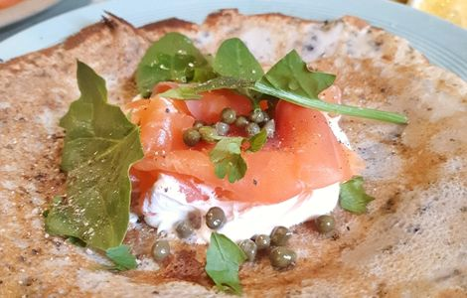
100g buckwheat flour
300ml milk
2 large eggs, beaten
1 x Laverbread 120g tin
50g Dragon Butter melted & cooled
200g Smoked Salmon
6 tbsp crème fraîche
1 lemon, juiced & zested
4 sprigs of dill and/or some spinach leaves (optional)

Put the flour, eggs, milk, butter, and a pinch of Halen Mon Sea Salt into a bowl & whisk to a smooth batter. Fold the Laverbread into the batter.
Set a frying pan over a medium heat and melt a knob of butter.
When hot, pour in your batter & cook the pancakes until golden on both sides, keeping them warm in a low oven as you go.
To make the toppings, mix the crème fraîche with the lemon juice - you could also add some dill here too. Top the pancakes with a dollop of lemony crème fraiche, some smoked salmon and capers or spinach.

Enjoy x

